Interpreting TurnitinUK Originality Reports

These instructions explain how to view and interpret TurnitinUK originality reports.

**Significance of matches within originality reports**

It is likely that work produced by students, at undergraduate level, will have some commonalities, as they are often writing on similar areas and using recommended texts. As a result, an originality report will be expected to contain some matches and, should only be used to detect plagiarism in conjunction with careful interpretation. The percentage match figure should be viewed with caution as it might not provide a true representation of the academic integrity of the work. For example, in a large document, a very small percentage may contain significant matches. Conversely, single page documents with a high similarity index may not indicate plagiarism. A document with a zero or small percentage match may actually indicate a lack of referencing of other sources.

Plagiarism is a matter of academic judgement. Originality reports should not be used as a sole determinant of plagiarism, but be used to aid lecturers to identify potential cases of plagiarism. Some resources are not available to the TurnitinUK database and require lecturers to use their own expertise to detect a suspected case of plagiarism. The TurnitinUK database comparison will identify all commonalities with submitted work, including students’ submissions across institutions; the originality report will show you from which institution the matches have come. Matches to other student assignments can be a result of both authors taking common extracts from the same text and as opposed to one student from the work of another, or collusion.

The decision to deem any work to be plagiarised should be made only after careful examination of both the submitted paper and the suspect sources taking into account all other evidence and the intent of the student. Students should be made aware that plagiarism can often be detected without the aid of TurnitinUK’s originality checking service.

**Allowing students to view originality reports**

The University promotes a formative and preventative use of TurnitinUK as a means of encouraging students to write and cite correctly. The option to make reports accessible in advance of the deadline and the option to resubmit are available when you set up a TurnitinUK assignment. More information on this is available in the **Creating a TurnitinUK assignment** information sheets. Before set up, check with your School/Programme Coordinator the preferred practice for your School.

Navigate to previous assignment

**Viewing the Originality Report Screen Layout**

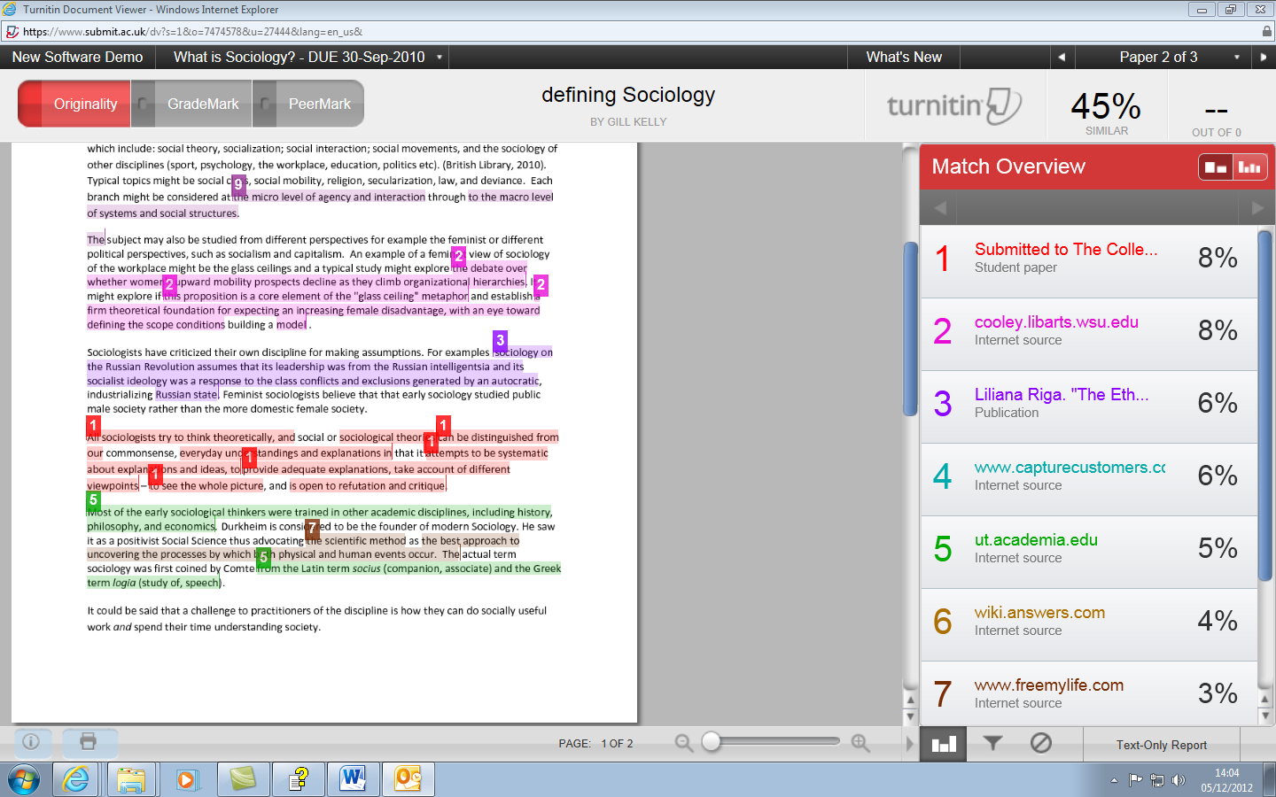

View and edit Filters

View all matching sources for the report

Old style report

Exclude and restore sources

Navigate to other submissions in your classes by this student

Click on a number to bring the associated source matches to the top of the document screen

Navigate to other submissions for this assignment

All sources for this match

Match overview

Scroll bar

Matches to first source are numbered 1 and colour coded

**Looking at all the matches to a particular source**

Percentage of Document which matches TurnitinUK Sources

1. To examine all the matches to the first source click on that source in the side bar (Figure 1).

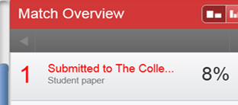

Figure 1: First match in side bar

1. A grey Match bar will appear above the first source match. Click on the **right arrow** of the bar to step through each match to the first source and a detailed comparison with the source text will appear above each match in the assignment window (Figure 2).

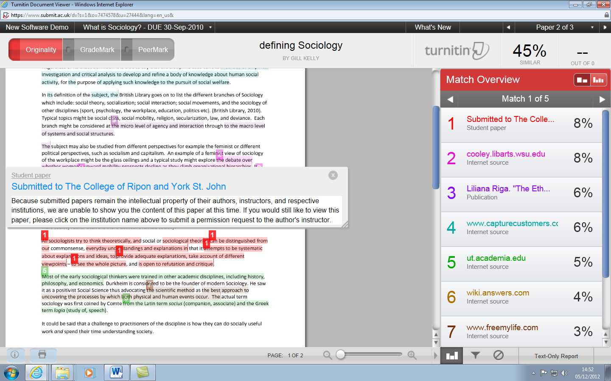

Figure 2: Match bar and detailed comparison

1. To examine all the matches to the second source click on the match numbered 2 in the side bar and use the right arrow on the match bar to step through them (Figure 2).

**To view underlying sources**

1. TurnitinUK will give you the source which incorporates the strongest match as the primary source but it will also have other sources that match the same text. To see all sources click on the ‘All Sources’ button (See figure 3).

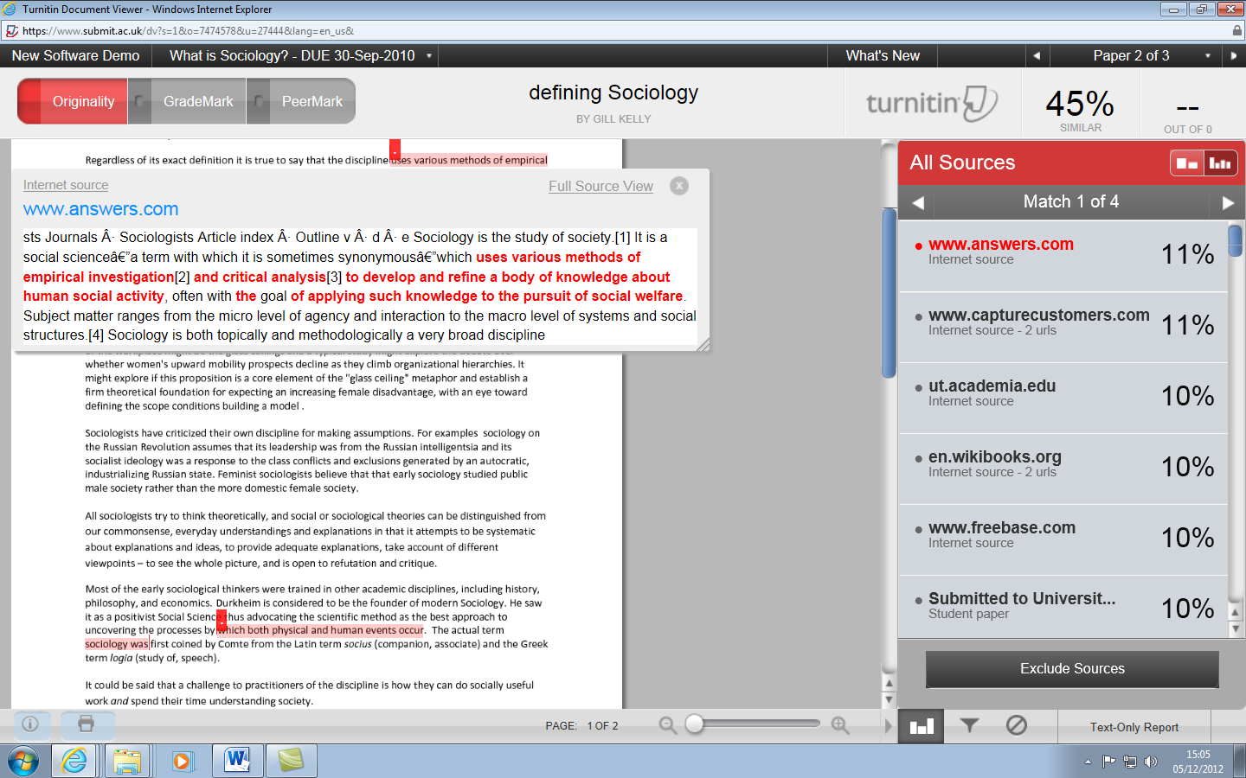

Figure 3: Viewing all sources

1. Within the ‘All Sources’ view you can link out to website containing the original source document.
2. To read the complete document click on ‘Full Source view’. (See figure 4).

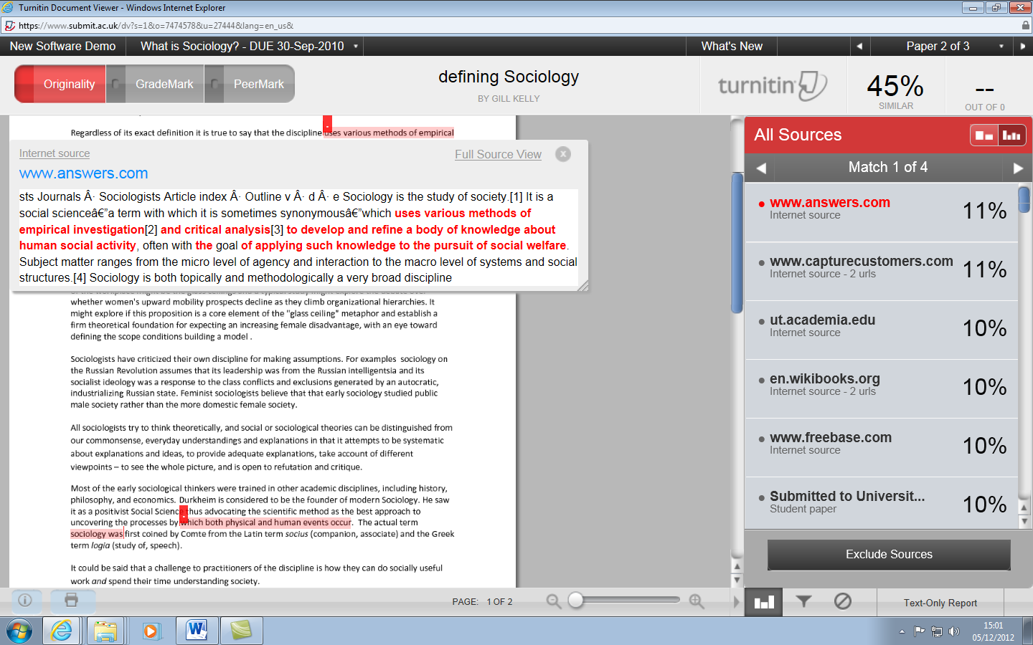

Figure 4: Viewing additional Sources

1. The student’s assignment will appear on the left with the relevant text highlighted. The original source will be displayed on the right, with the corresponding text highlighted in red. (See figure 5).

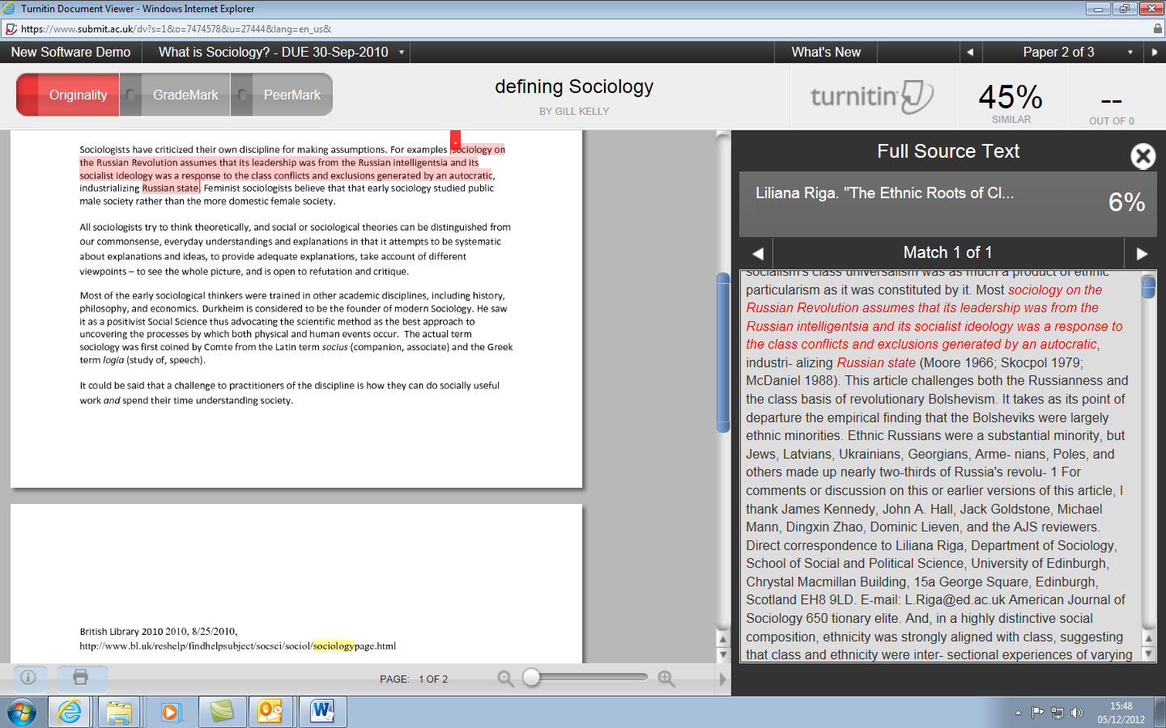

Figure 5: Full Source View

# Using the filtering functionality

# To Exclude Matches to References (Also quotations and small matches)

1. Click on the View/edit filters and settings symbol at the bottom right hand side of the screen which appear as a funnel (See Figure 4).

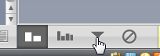

Figure 6: View/edit filters and setting symbol

1. Click ‘Exclude Bibliography’on the Filters and Settings side panel (Figure 5).

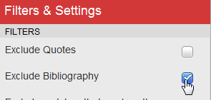

Figure 7: Excluding the bibliography

1. Click on ‘Apply Changes’ at the bottom of the panel. This is a picture of the 'apply changes' button
2. The Similarity Index should decrease.
3. Matches to quotations and small matches may be excluded in the same way.

# Eliminating and restoring sources

1. In some cases, matches may be the result of an assignment mistakenly being uploaded more than once, either by the tutor, or the student. The result may be that matches highlighted are in fact the same piece of work. It is possible to exclude the duplicated assignment when creating a report by excluding it from the search. (See figure 8).

It is important to note the difference between matches to a duplicate assignment which should be excluded, and matches to work by the same author that has been reused to fulfil requirements of a different assignment, which should not.

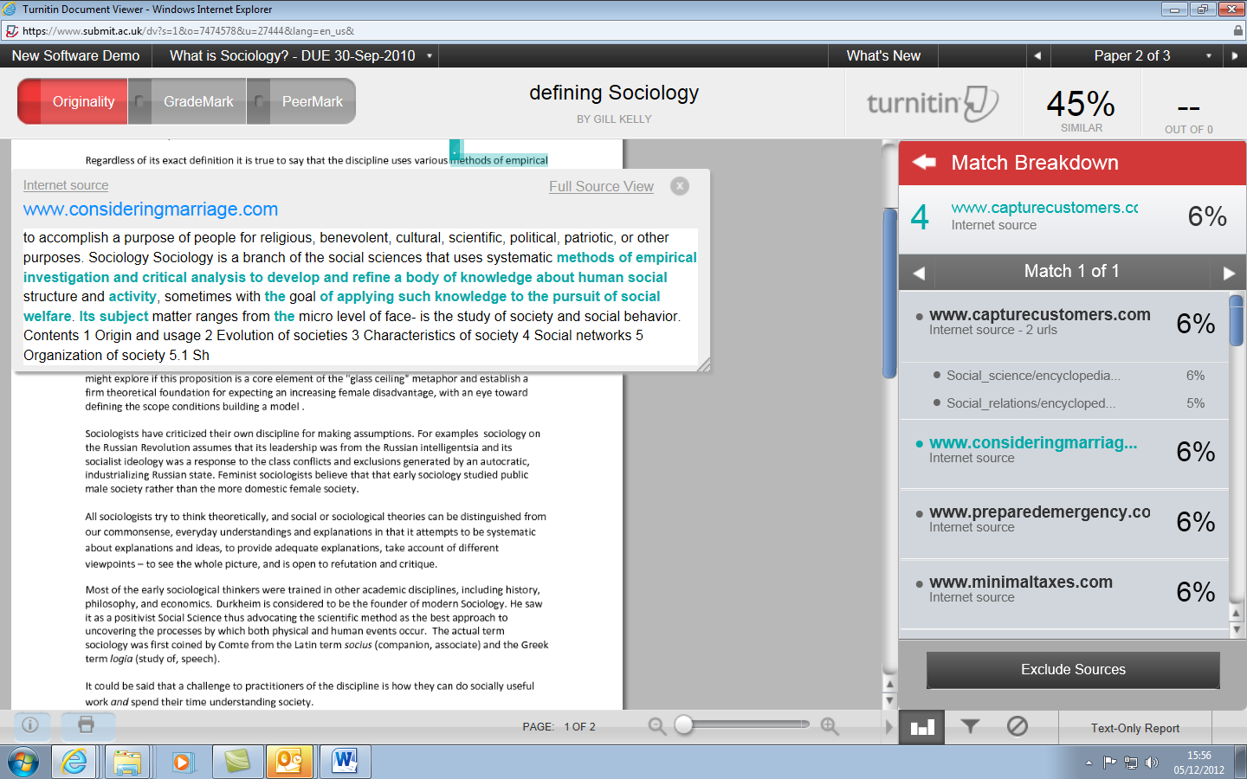

Figure 8: Excluding Sources

1. If there are a number of matches you can select those you wish to exclude. (See figure 9).

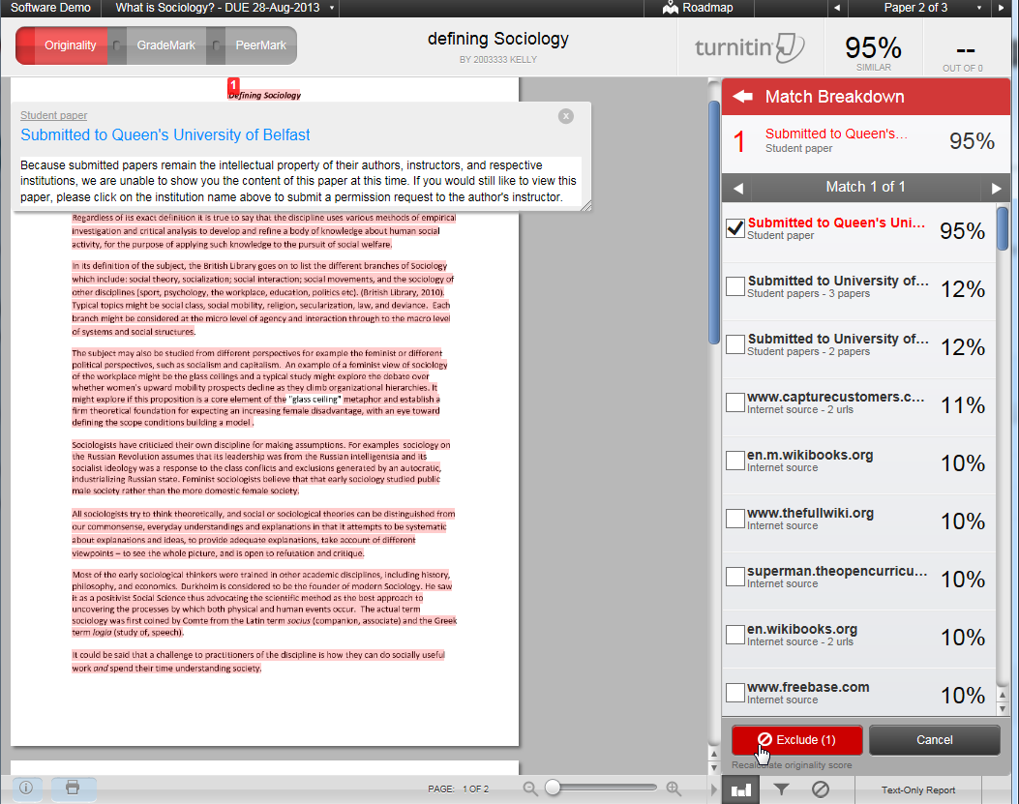

Figure 9: Excluding selected sources

1. To restore excluded sources click on the ‘Exclude and Restore Sources’ button. 
2. Select the sources you wish to restore and click on the ‘Restore’ button. To return all excluded sources click the ‘Restore All’ button. (See figure 10).

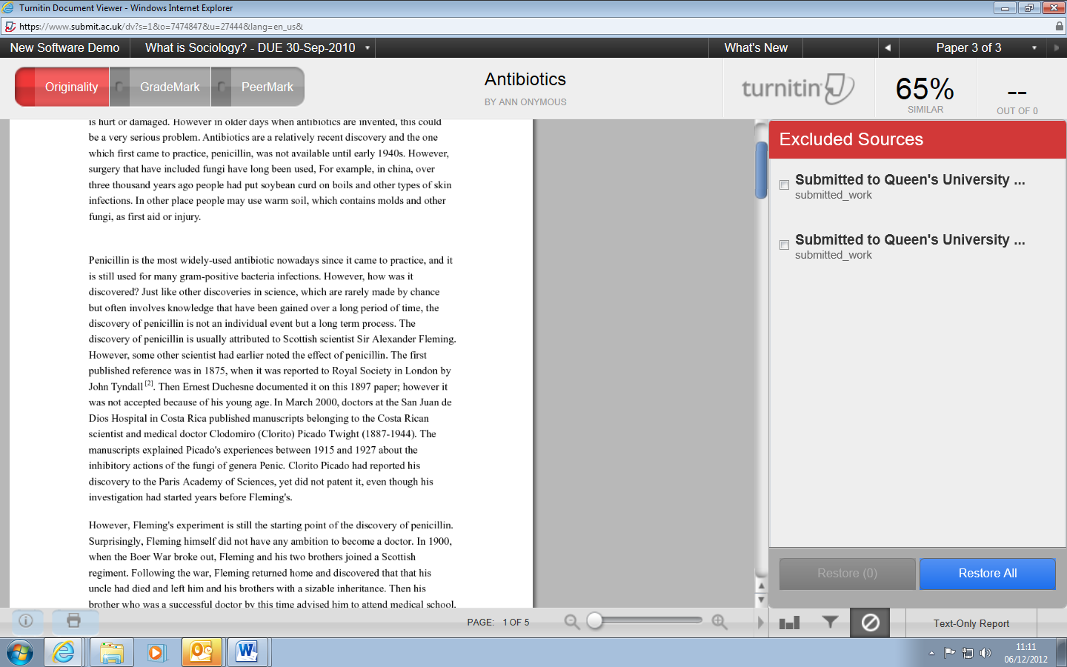

Click on Restore or Restore All

Tick the sources you wish to restore

Figure 10: Restore excluded resources